Yr11 Physics 

Topic Test : Nuclear Physics : Solutions: 48 marks

Name: Class: Date: __________

48 marks

Question 1 (1 mark)

Which of the following travels at the greatest speed?

A gamma radiation

B beta radiation

C alpha radiation

D they all travel at the same speed

1. *Gamma radiation is electromagnetic radiation and therefore travels at the speed of light:*

*3 × 108 m s–1.*

Question 2 ( 1mark)

Which of the following best describes beta-minus radiation?

A energy emitted from an electron of an atom

B an electron ejected from an atom

C a helium nucleus emitted from an atom

D an electron emitted from the nucleus of an atom

*D. Radiation is always emitted from a nucleus. A beta-minus particle is a high-speed electron   
ejected from a nucleus when a neutron decays into a proton.*

Question 3 ( 1 mark)

Which of the following options is the most penetrating form of radiation?

A gamma

B beta

C alpha

D none of the above

1. *Gamma; it can penetrate through several metres of concrete.*

Question 4

For two nuclei to undergo fusion, which of the following must be overcome? (1 mark)

A strong nuclear force

B electrostatic force

C binding force

D weak nuclear force

*B. The electrostatic repulsive force must be overcome for the particles to get close enough to fuse.*

Question 5

Which of the following is responsible for holding the nucleus of an atom together?

A strong nuclear force

B weak nuclear force

C binding force

D electrostatic force

E gravity

*A. The strong nuclear force overcomes the repulsive electrostatic force inside the nucleus. (1 mark)*

Question 6

For the following radioisotope, calculate the number of:

**i** protons; **ii** neutrons; **iii** nucleons.

 (3 marks)

*i 95 ii 146 iii 241*

Question 7

1. Strontium-90 is one of the radioisotopes that was released during the Fukushima nuclear disaster in Japan. Strontium-90 has a half-life of 28.8 years.

If 1.8 × 1010 atoms of strontium-90 were released during the accident, calculate how many of the original strontium-90 nuclides will still be in existence in 144 years? ( 2 marks)

*144 years is 5 half-lives, so the amount remaining is:* * = 5.6 × 108*

1. A radioactive sample of oxygen-15 has a half-life of 110 minutes. If the amount of oxygen-15 remaining after 5.5 hours is 0.80 g, calculate the mass of the original sample.

*5.5 hours = 330 minutes = 3 × 110 minutes = 3 half-lives*

*The mass has halved three times from its original amount.*

*Hence the original amount = 2 × 2 × 2 × 0.80 = 23 × 0.80 = 6.4 g. (3 marks)*

**(c)**  A scientist uses a Geiger counter to measure the radiation of a radioactive sample. She records the count as 90 000 emissions per minute.

**a** Calculate the activity of the sample in becquerel (Bq). (1 mark)

*Activity is emissions per second =  = 1500 Bq* (1 mark)

Question 8

a Rank the following forms of radiation from least ionising to most ionising: (1 mark)

beta, alpha, gamma.

*gamma, beta, alpha**(1 mark)*

b. Explain your answer

*b All of the types of radiation listed can ionise atoms. The ionising ability depends on charge. Gamma radiation has no charge so is least effective. Beta-minus has a charge of –1 and beta-plus has a charge of +1. Alpha radiation has the highest charge of all radiation types (+2) and so is the most ionising.* (2 marks)

Question 9

In the following decay equations determine the unknown, *X*?

a  (1 mark)

b  (1 mark)

Question 10

When bombarded with neutrons, gold (Au-197) undergoes neutron absorption to become the radioactive isotope gold-198. Given that gold has an atomic number of 79, write a balanced equation for the following:

**a** the absorption of a neutron by a gold-197 atom (2 marks)



**b** the beta decay of a radioactive nucleus of gold-198. (2 marks) 

Question 11

An 85 kg man is exposed to 250 mJ of gamma radiation. Calculate:

a absorbed dose =  = 0.00294 Gy = 2.94 mGy (1 mark)

b dose equivalent = absorbed dose × quality factor = 2.94 × 10–3 × 1 = 2.94 mSv (1 mark)

c The quality factor for alpha = 20, and the quality factor for gamma = 1, so the dose equivalent is 20 times greater.

Therefore the dose equivalent = 20 x 2.94 × 10–3 = 0.0588 Sv = 58.8 mSv (1 mark)

d energy, *E* = 250 mJ =  = 1.56 × 1018 eV (1 mark)

Question 12

The radioactive decay of a particular isotope is shown on the graph below. The initial mass of the radioisotope is 40 g. Use the graph to help answer the following questions.

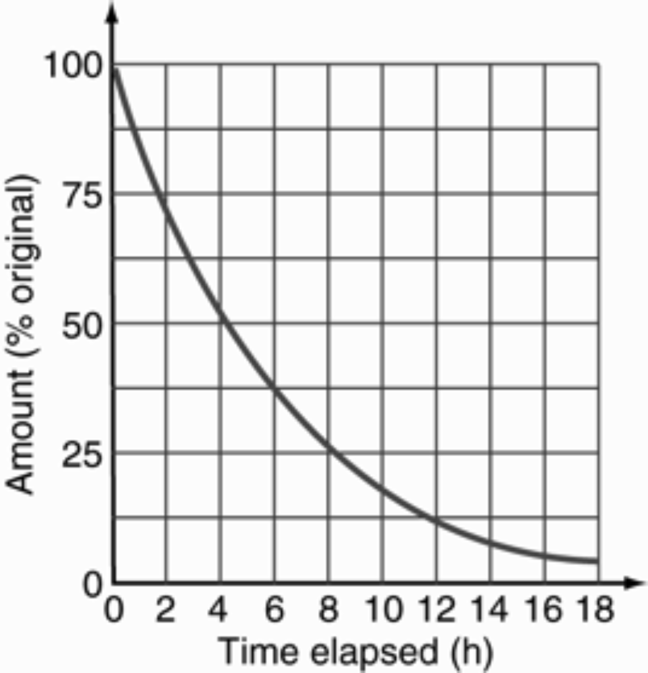

**a** Find the time it takes for a 40 g sample to decay to 10 g.

*a 10 g is 25% of 40 g*

*Therefore, reading from the graph, the time taken is 8 hours. (1 mark)*

**b** Find the half-life of the sample. *The half-life is the time for 50% of the sample to decay = 4 hours. (1 mark)*

**c** **From the graph**, find how much of the original radioisotope (in grams) remains after 10.0 hours.

c *Reading from the graph, after 10 hours, 18% remains. (1 mark)*

*18% of 40 g ≈ 7.2 g (1 mark)*

Question 13

aA scientist is using a Geiger counter to examine a locked box made of very thin aluminium. The Geiger counter detects some radiation being emitted through the top of the box. Without opening the box, the scientist puts a thick sheet of aluminium around the box and finds that the activity registered by the Geiger counter reduces. What type(s) of radiation could be present? (Assume neutrons are not present.)

*The radiation could be beta radiation and/or gamma radiation. (2 marks)*

*Beta radiation would be reduced by increasing the thickness of the aluminium, but gamma radiation will continue to penetrate.*

b The scientist then puts a strong magnetic field across the box. She finds that the direction of the radiation changes and there is no radiation in the original direction. What type of radiation is it, and why?

*The magnetic field will bend the path of radiation that is charged. Beta radiation is negatively charged, but gamma radiation is uncharged.   
Therefore the radiation has to be beta radiation. (2 marks)*

Question 14

Consider the following fission reaction:



a Convert the energy released into joules.

E *= (170 × 106) × (1.6 × 10–19) = 2.72 × 10–11 J (1 mark)*

b For each nuclei of uranium-235 calculate how much mass (in kg) was converted to energy in the reaction?

E *=* mc*2 (consequential answer)*

m *=  = 3.02 × 10–28 kg* (2 marks)

d Using the fact that 1.00 kg of uranium-235 contains 2.5 × 1024 nuclei, how much energy would be released if all the nuclei in 1.00 kg of uranium-235 underwent fission?

c E *= (170 × 106) × (1.6 × 10–19) × (2.5 × 1024) (1 mark)*

*= 6.80 × 1013 J (1 mark)*

Question 15

One of the reactions that takes place in a fusion reactor is shown below:



a How many neutrons are released during this reaction (i.e. what is the value of )?

*Balancing the mass numbers, one neutron has been released.* (1 mark)

b How does the combined mass of the reactants compare with the combined mass of the products in this fusion reaction? (No calculation required)

*The combined mass of the products is slightly less than that of the reactants. (2 marks)*

**c** What happens to this difference in mass?

*The difference in mass accounts for the energy released in the reaction according   
to E = mc2.* (1 mark)

d One of the fusion reactions taking place inside the Sun is shown below:



Identify the missing nuclide, *X*.

***d*** *The missing nuclide has an atomic number of 2 and a mass number of 4, so is . (2 marks)*